Heart Disease Prediction
End-to-End MLOps Project Documentation
A Complete Machine Learning Operations Pipeline for Healthcare Analytics
Link to code repository: - https://github.com/mkt-mohit/mlops-heart-prediction
Deployed API url: - https://mlops-group113-82241217806.asia-south1.run.app/predict

Executive Summary

This project presents a production-ready machine learning system for predicting heart disease risk using patient health metrics. The implementation follows industry-standard MLOps practices, incorporating automated CI/CD pipelines, containerized deployment, and comprehensive monitoring capabilities. The final model is deployed as a scalable REST API on Google Cloud Run, demonstrating enterprise-grade machine learning deployment strategies.

Project Objectives:

Build a reliable binary classification model for heart disease prediction
Implement reproducible ML workflows with experiment tracking
Create automated testing and deployment pipelines
Deploy a production-ready API with monitoring capabilities

Setup and Installation Instructions

Prerequisites

Before beginning the setup process, ensure the following requirements are met:

Python 3.12 or higher installed on your system
Git for version control
Google Cloud Platform account with billing enabled
GitHub account for repository hosting and CI/CD

Docker installed (optional, for local containerization testing)

  - Repository Setup

# Clone the repository git clone https://github.com/<your-
username>/<repo-name>.git cd <repo-name> # Create virtual environment python -m venv venv # Activate virtual environment source
venv/bin/activate # Linux / macOS venv\Scripts\activate # Windows

  - Dependency Installation

# Install required packages pip install -r requirements.txt # Verify installation python -c "import sklearn, fastapi, mlflow; print('All dependencies installed successfully')"

  - Local Development Setup

For local testing and development of the API:

# Start the FastAPI development server uvicorn app.main:app --reload #
API will be available at: http://localhost:8000 # Interactive API documentation: http://localhost:8000/docs

Cloud Deployment Configuration

Configure Google Cloud Platform for automated deployment:

    - Create a new GCP project or select an existing one
    - Enable Cloud Run API and Container Registry API
    - Create a service account with Cloud Run Admin and Storage Admin roles
    - Generate and download the service account key as JSON
    - Add the following secrets to your GitHub repository:
GCP_PROJECT_ID: Your GCP project identifier
GCP_SA_KEY: Service account JSON key (base64 encoded)

CD
==
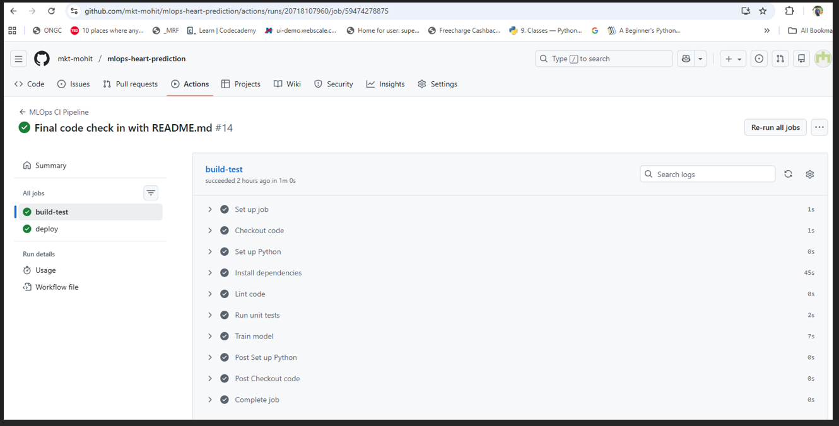
CD
===

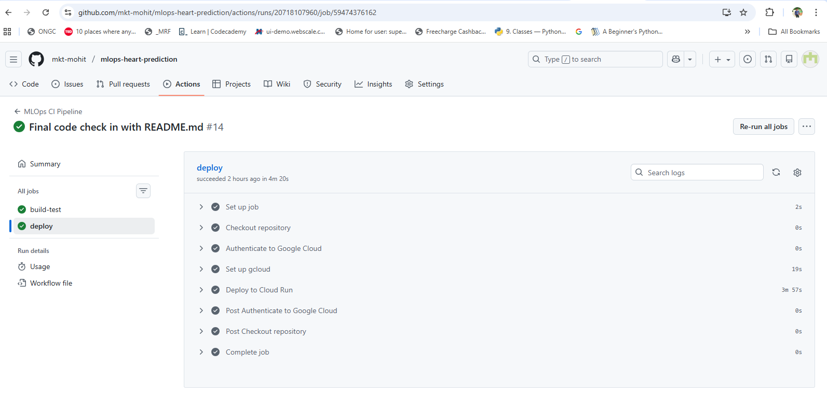

Automated Deployment: Once configured, pushing to the main branch automatically triggers the CI/CD pipeline, running tests, building containers, and deploying to Cloud
Run.

Build History
==========
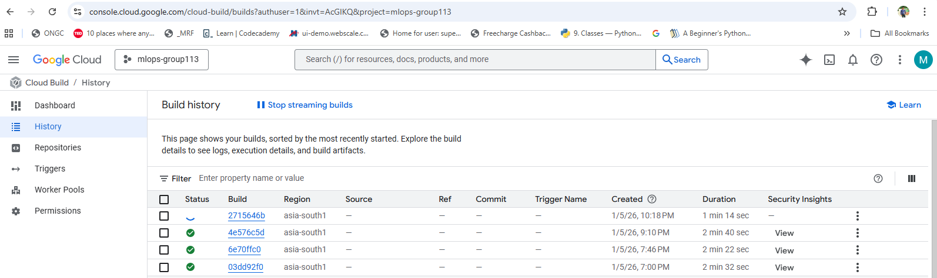

Exploratory Data Analysis (EDA) and Data Preprocessing

Dataset Overview

The project utilizes the UCI Heart Disease dataset, a well-established benchmark in medical machine learning research. The dataset contains 303 patient records with 13 clinical features relevant to cardiovascular health assessment.

Attribute  age | Description  Patient age in years | Data Type  Integer
sex | Gender (1 = male, 0 = female) | Binary
cp | Chest pain type (0-3) | Categorical
trestbps | Resting blood pressure (mm Hg) | Integer
chol | Serum cholesterol (mg/dl) | Integer
fbs | Fasting blood sugar > 120 mg/dl | Binary
restecg | Resting ECG results (0-2) | Categorical
thalach | Maximum heart rate achieved | Integer
exang | Exercise induced angina | Binary
oldpeak | ST depression induced by exercise | Float
slope | Slope of peak exercise ST segment | Categorical
ca | Number of major vessels (0-3) | Integer
thal Thalassemia type (0-3) Categorical

Data Quality Assessment

During the exploratory phase, the following data quality checks were performed:

Missing Values: Identified and handled missing values using domain-appropriate imputation strategies
Outlier Detection: Statistical analysis to identify and address outliers in continuous variables
Class Distribution: Analyzed target variable distribution to assess class balance
Feature Correlations: Examined inter-feature relationships to identify multicollinearity

Feature Engineering Strategy

Step 1: Numerical Feature Scaling

Applied StandardScaler to normalize continuous variables (age, blood pressure, cholesterol, heart rate, oldpeak), ensuring features contribute proportionally to model training.

Step 2: Categorical Encoding

Used appropriate encoding techniques for categorical variables (chest pain type, ECG results, slope, thalassemia) to convert them into numerical representations suitable for machine learning algorithms.

Step 3: Target Variable Transformation

Converted the multi-class target variable into a binary classification problem (0 = no disease, 1 = disease present) to align with project objectives.

Modeling Choices and Rationale

Algorithm Selection

Two machine learning algorithms were evaluated for this binary classification task, each selected for specific advantages in healthcare prediction scenarios:

Logistic Regression Random Forest
Interpretable coefficients Handles non-linear relationships
Probabilistic predictions Feature importance ranking
Fast training and inference Robust to outliers
Baseline performance benchmark Reduced overfitting risk

Model Training Pipeline

A scikit-learn Pipeline was constructed to ensure reproducibility and prevent data leakage. The pipeline encapsulates preprocessing steps (scaling, encoding) and the model, guaranteeing that all transformations applied during training are consistently applied during inference.

Model Evaluation Strategy

Model performance was assessed using cross-validation with the following metrics:

Accuracy: Overall prediction correctness across all classes
Precision: Proportion of positive predictions that were correct (minimizing false positives)
Recall: Proportion of actual positives correctly identified (minimizing false negatives)
F1-Score: Harmonic mean of precision and recall for balanced assessment
ROC-AUC: Model's ability to discriminate between classes across different thresholds

Cross-validation with 5 folds was employed to ensure robust performance estimates and reduce variance in evaluation metrics. The Random Forest model was selected as the final production model based on superior cross-validation performance.

Model Serialization

The final trained pipeline (including preprocessing steps and the Random Forest classifier) was serialized using Python's pickle module and saved as random_forest_final.pkl. This artifact encapsulates the complete prediction workflow, ensuring consistency between training and deployment environments.

Experiment Tracking Summary

MLflow Integration

MLflow was implemented as the experiment tracking solution to provide comprehensive visibility into model development iterations. This platform enables systematic comparison of different model configurations and hyperparameter settings.

Tracked Artifacts

For each experiment run, the following information was logged:

Category  Parameters | Tracked Elements  Model hyperparameters (n_estimators, max_depth, random_state), preprocessing configurations, train-test split ratios
Metrics | Accuracy, Precision, Recall, F1-Score, ROC-AUC, Cross-validation mean and standard deviation
Artifacts | Serialized model files, preprocessing pipelines, feature importance plots, confusion matrices
Metadata | Training duration, dataset version, execution environment details

Benefits of Experiment Tracking

Reproducibility: Complete record of experiments enables exact replication of results
Comparison: Side-by-side analysis of different model configurations
Model Registry: Centralized storage for trained models with version control
Collaboration: Team members can access and review all experiments
Audit Trail: Historical record of model development decisions

MLflow UI Access: The MLflow tracking server provides a web interface for visualizing experiments. Launch locally using mlflow ui and access at http://localhost:5000

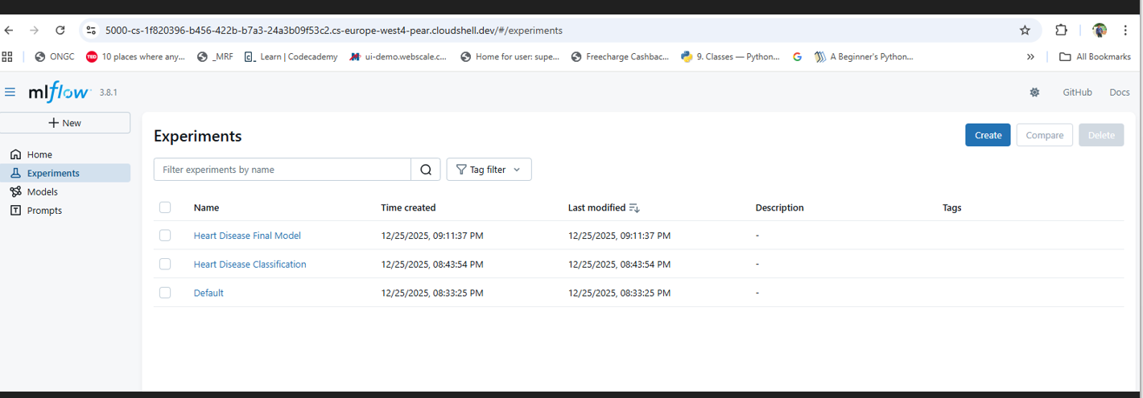

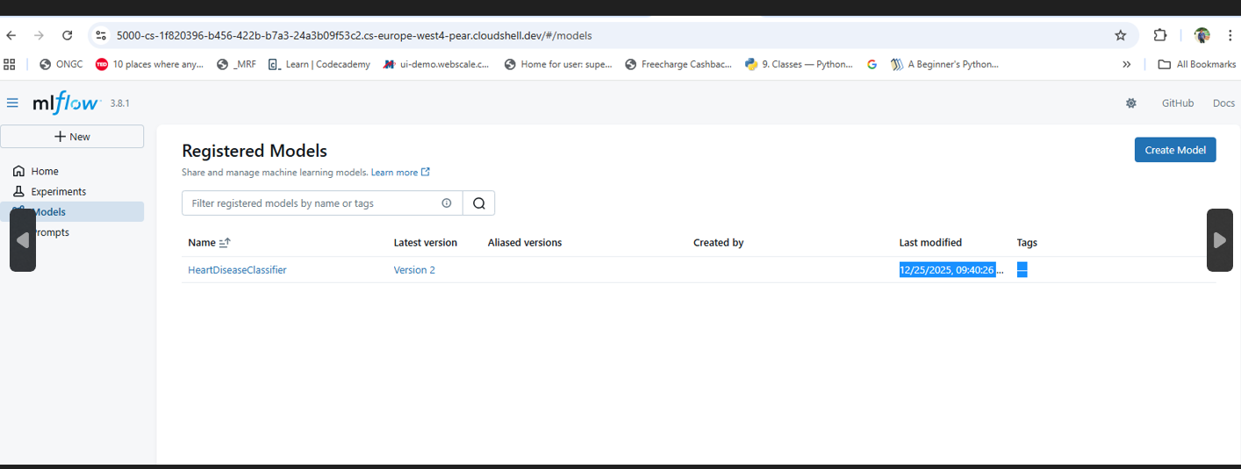

Architecture Diagram

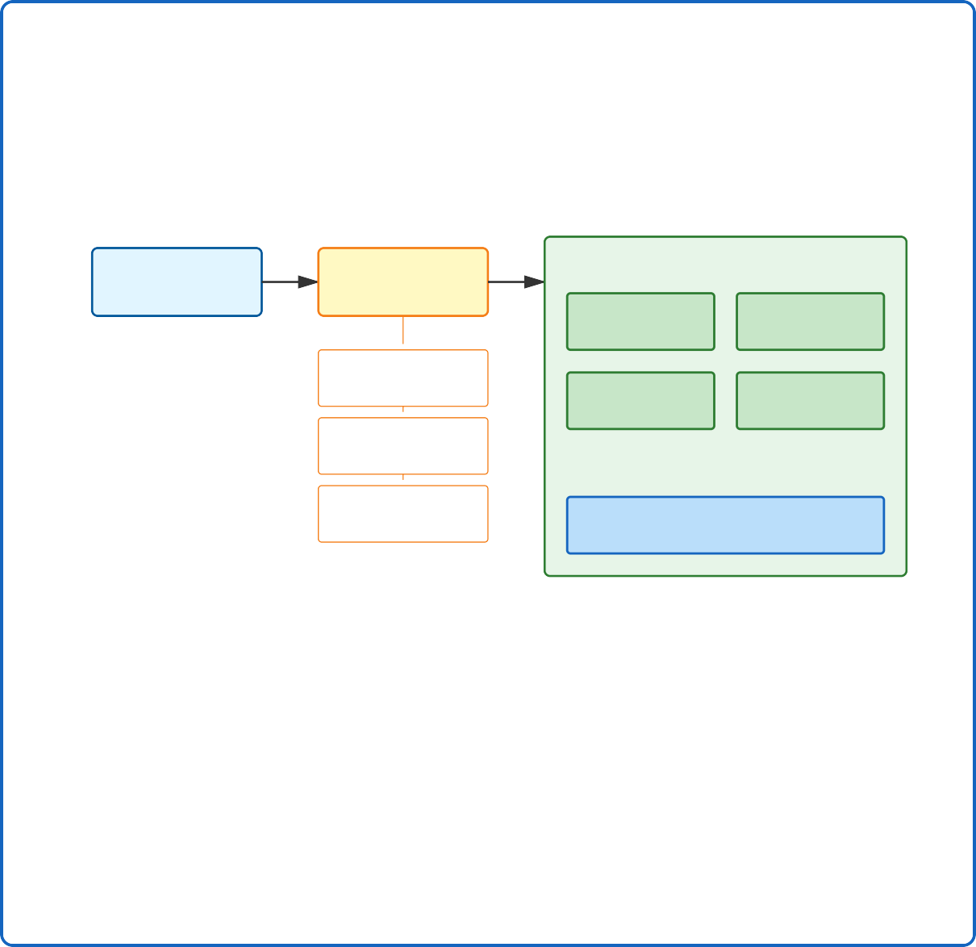
System Architecture Flow
GitHub
Repository
git push
GitHub Actions
CI/CD Pipeline
deploy
Google Cloud Run
FastAPI REST API
Docker Container
Linting (flake8)
Auto-scaling
Cloud Logging
& Metrics
Unit Tests (pytest)
Model Training Check
End Users / API Consumers
Data Flow:
- Code pushed to GitHub repository
- GitHub Actions runs CI/CD pipeline
- Tests, linting, and training validation
- Containerized deployment to Cloud Run
- Scalable API serving with monitoring

- CI/CD and Deployment Workflow

Continuous Integration Pipeline

The GitHub Actions workflow automates quality assurance and deployment processes. Each code push triggers a sequence of validation steps before deployment proceeds.

Pipeline Stages

Stage 1: Code Quality Checks
Linting: flake8 enforces PEP 8 style guidelines
Code formatting: Ensures consistent code structure
Static analysis: Identifies potential code issues

Stage 2: Automated Testing
Unit tests: pytest validates individual components
Data validation: Verifies data loading and preprocessing
Model tests: Confirms model loading and prediction functionality

Stage 3: Model Validation
Training sanity check: Validates model can train successfully
Prediction verification: Ensures model generates valid outputs
Performance threshold: Confirms minimum accuracy requirements

Stage 4: Containerization
Docker build: Creates optimized container image
Image registry: Pushes to Google Container Registry
Security scanning: Checks for vulnerabilities

Stage 5: Cloud Deployment
Cloud Run deployment: Updates production service
Traffic management: Gradual rollout to minimize risk
Health checks: Validates deployment success

  - Deployment Configuration

# GitHub Actions workflow excerpt name: CI/CD Pipeline on: push:
branches: [ main ] jobs: test-and-deploy: runs-on: ubuntu-latest steps: - name: Checkout code - name: Run linting - name: Execute tests - name:
Build Docker image - name: Deploy to Cloud Run

API Documentation

  - Endpoint Specifications Health Check Endpoint

GET / Response: { "status": "ok", "message": "Heart Disease Model is running" }

Prediction Endpoint

